Data Analysis Project

Steps

* Created a Problem Statement.
* Identified the data wanted to analyse.
* Explored and cleaned the data.
* Analysed the data to get useful insights.
* Present the data in terms of reports or dashboards using visualization.

Business Problem

In recent years, City Hotel and Resort Hotel have seen high cancellation rates. Each hotel is now dealing with a number of issues as a result, including fewer revenues and less than ideal hotel room use. Consequently, lowering cancellation rates is both hotels' primary goal in order to increase their efficiency in generating revenue, and for us to offer thorough business advice to address this problem.

The analysis of hotel booking cancellations as well as other factors that have no bearing on their business and yearly revenue generation are the main topics of this report.

Assumptions

1. No unusual occurrences between 2015 and 2017 will have a substantial impact on the data used.

2. The information is still current and can be used to analyse a hotel's possible plans in an efficient manner.

3. There are no unanticipated negatives to the hotel employing any advised technique.

4. The hotels are not currently using any of the suggested solutions.

5. The biggest factor affecting the effectiveness of earning income is booking

cancellations.

6. Cancellations result in vacant rooms for the booked length of time.

7. Clients make hotel reservations the same year they make cancellations.

Research Question

1. What are the variables that affect hotel reservation cancellations?

2. How can we make hotel reservations cancellations better?

3. How will hotels be assisted in making pricing and promotional decisions?

Hypothesis

1. More cancellations occur when prices are higher.

2. When there is a longer waiting list, customers tend to cancel more frequently

3. The majority of clients are coming from offline travel agents to make their

reservations.

Analysis and Findings

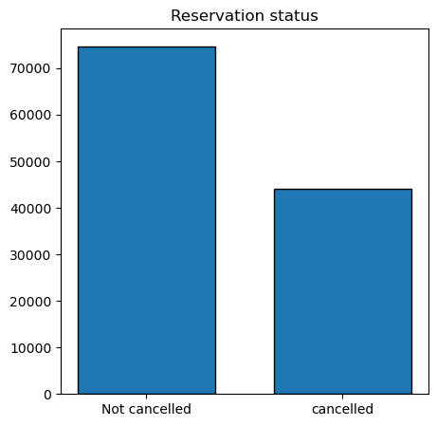

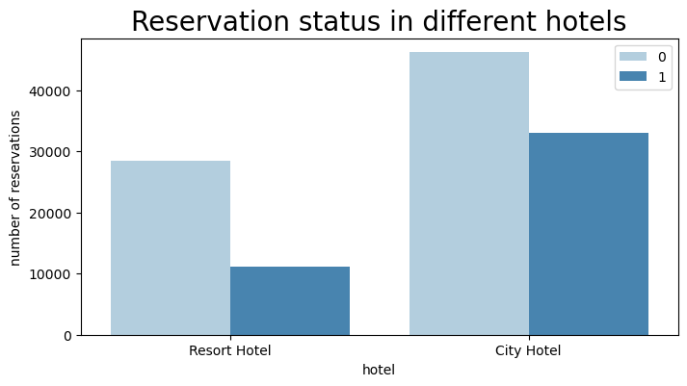The accompanying bar graph shows the percentage of reservations that are cancelled and those tat are not. It is obvious that there are still significant number of reservations that have not been cancelled. There are still 37% of clients who cancelled their reservations, which has significant impact on the hotel’s earnings

In comparison to Resort hotel The City hotel has more bookings. It’s possible that resort hotel is more expensive than city hotel

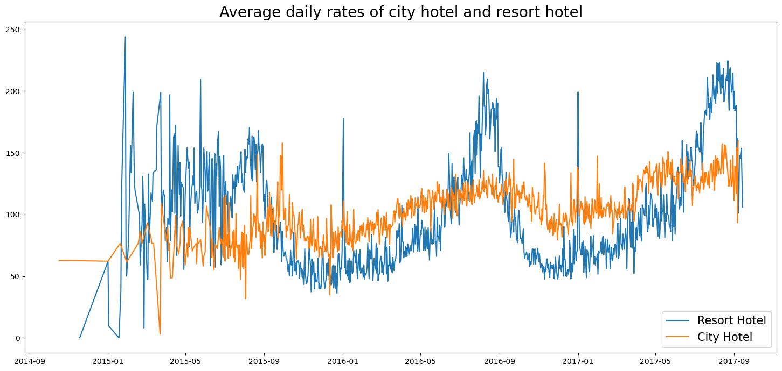

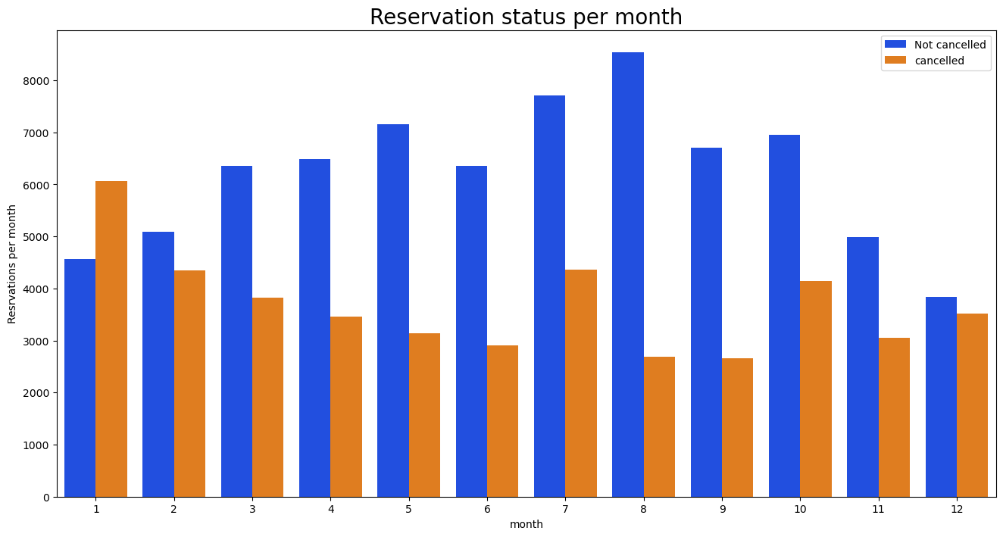The line graph above shows that, on certain days the average daily rates for city hotel is less than that of resort hotel and on the other days it is even less. It goes without saying that weekends or holidays may see a rise in the resort hotel rates.

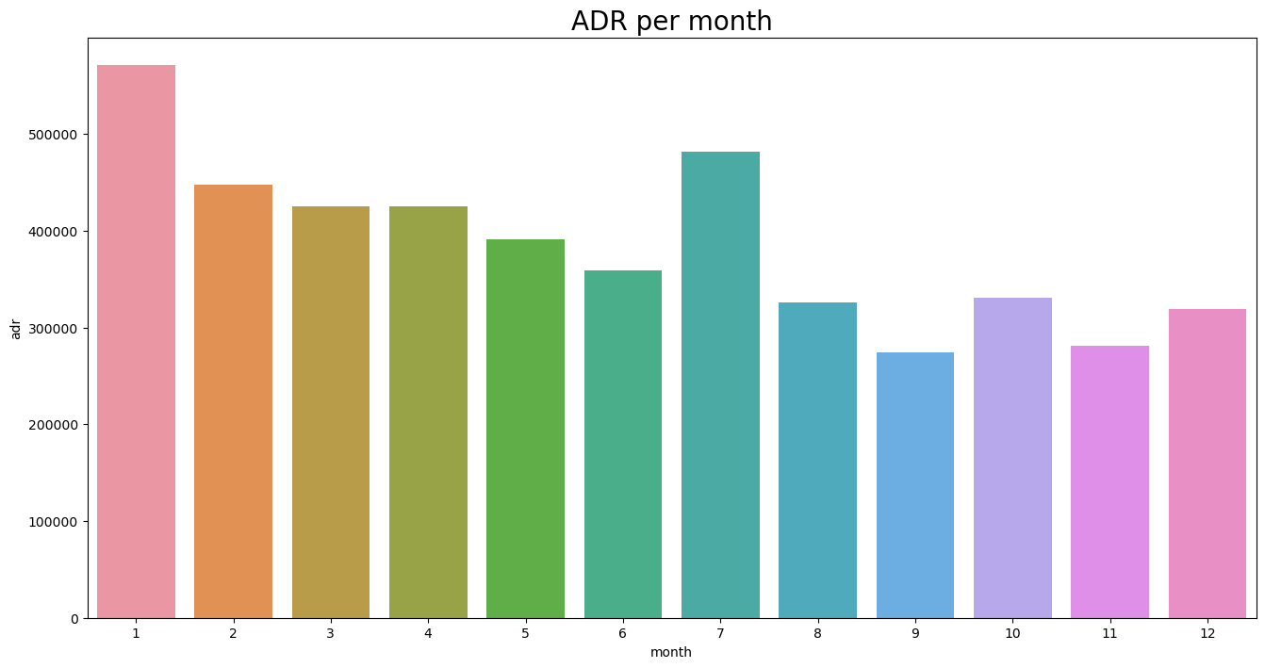We have developed the grouped bar graph to analyse the months with the highest and lowest reservation status. As can be seen, both the both the number of confirmed reservations and cancelled reservations are largest in the month of august. Whereas January is the month of most cancelled reservations

This bar graph demonstrates that cancellations are most common when prices are greatest and are least common when they are lowest

Therefore, the cost of accommodation is solely responsible for reservation cancellation.

Now let’s see which country has the highest reservations cancelled. The top country is the Portugal with highest number of cancellations

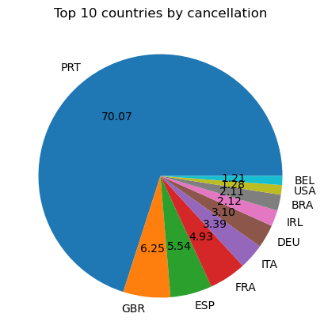

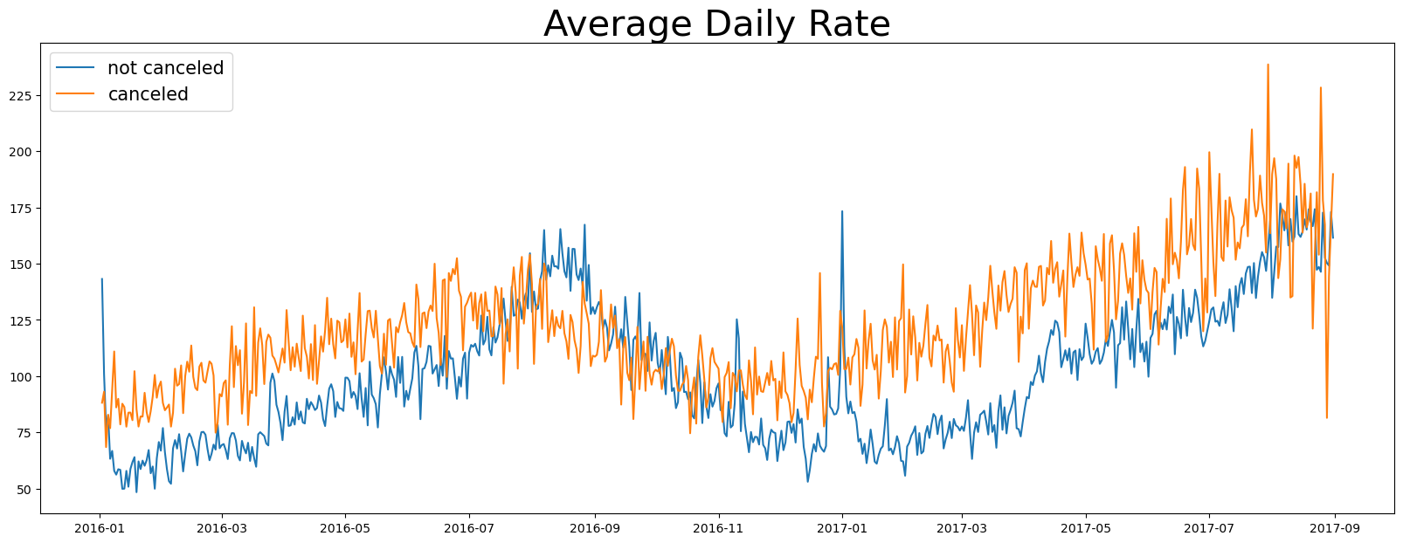Let’s check the area from where the guests are visiting the hotels and making the reservations.is it coming from direct or groups, online or offline travel agents? Around 46% of the clients come from online travel agencies, whereas 27% come from groups, only 4% books directly by visiting the hotels and make the reservations.

As seen in the graph, reservations are cancelled where the average daily rate is higher than when it is not cancelled. It clearly proves all the above analysis that the higher price leads to higher cancellations.

Suggestions

1. cancellations rates raise as the price does. In order to prevent cancellations of reservations hotels could work on their pricing strategies and try to lower the rates for specific hotels based on locations. They can also provide some discounts to the consumers
2. As the ratio of cancellation and not cancellation of resort hotel is higher than that of the city hotel so the hotels should provide reasonable discount on the room prices on weekends or on holidays.
3. In the month of January the hotels can start campaigns or marketing with reasonable amount to increase the revenue as the cancellation is highest in this month
4. They can also increase the quality of their hotels and their services mainly in the Portugal to reduce the cancellations rate